The wish list process organizes the process of working through a design process, consisting of potentially many helper functions. The moment at which the last helper is finished, and "all tests pass" is very satisfying.

Working through the wish list: larger? Function

larger? Function must:

* Consume 2 images
* Operate on width and height of both images

**Examples:**

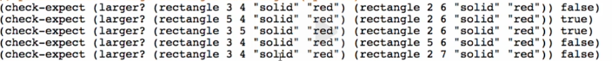

* we need 2 more examples

**Template:**



**Code-body:**



Test and debug!

Overview:

